

1

|  |  |
| --- | --- |
| **Product Category** | **Sales** |
| Bread & Bakery | $ 1000 |
| Dairy | $ 800 |
| Meat | $ 900 |
| Frozen Food | $ 650 |
| Seafood | $ 500 |
| Beverages | $ 800 |
| Produce | $ 730 |
| Personal Care | $ 220 |
| Total | $ 5600 |

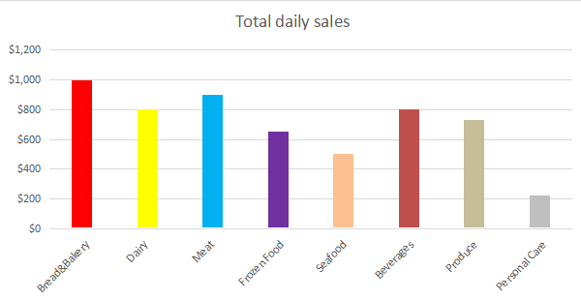

|  |  |
| --- | --- |
| **Product Category – Bread and Bakery** | **Sales** |
| Cakes | $ 120.00 |
| Cookies | $ 290.00 |
| Donuts | $ 270.00 |
| Bread | $ 320.00 |
| Total | $ 1000.00 |

